Creating IAM users using terraform(loops)

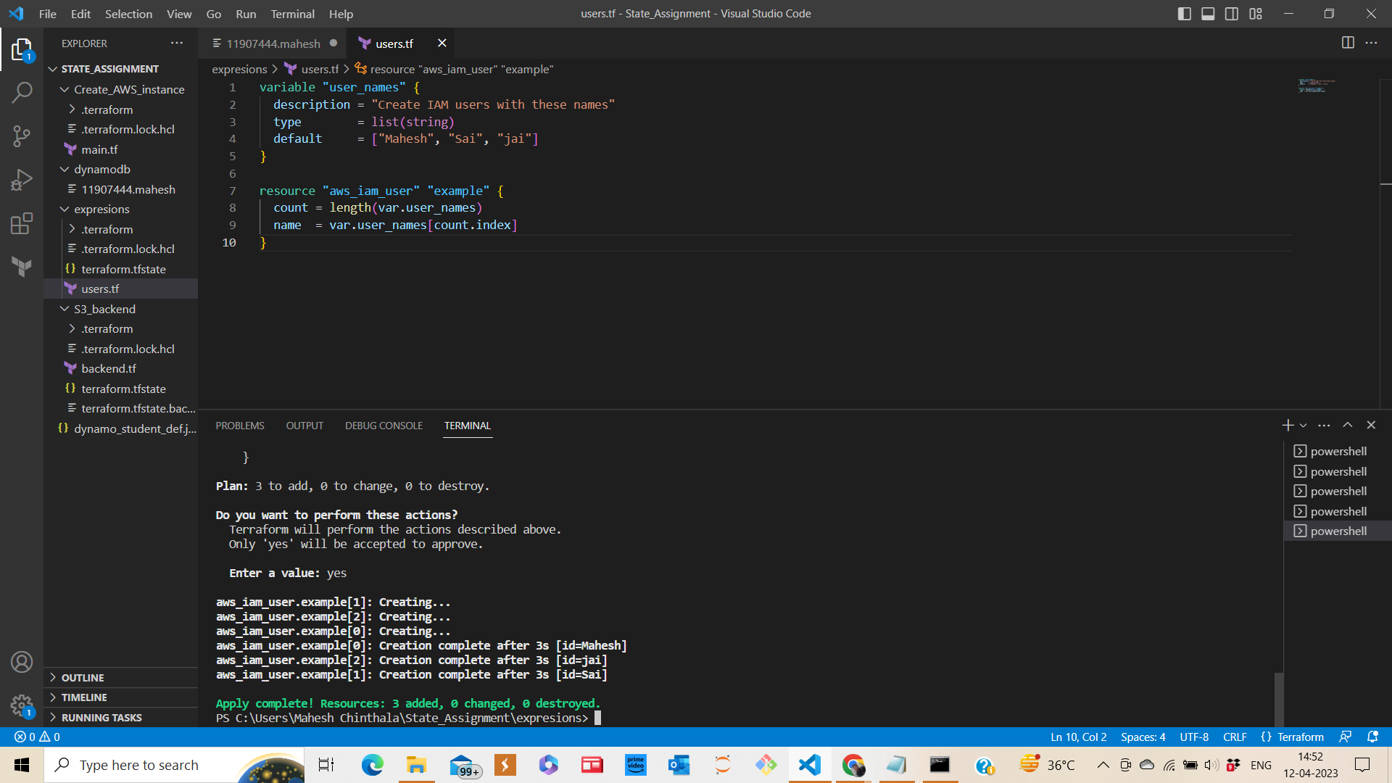

I have given user names as Mahesh, Sai, Jai

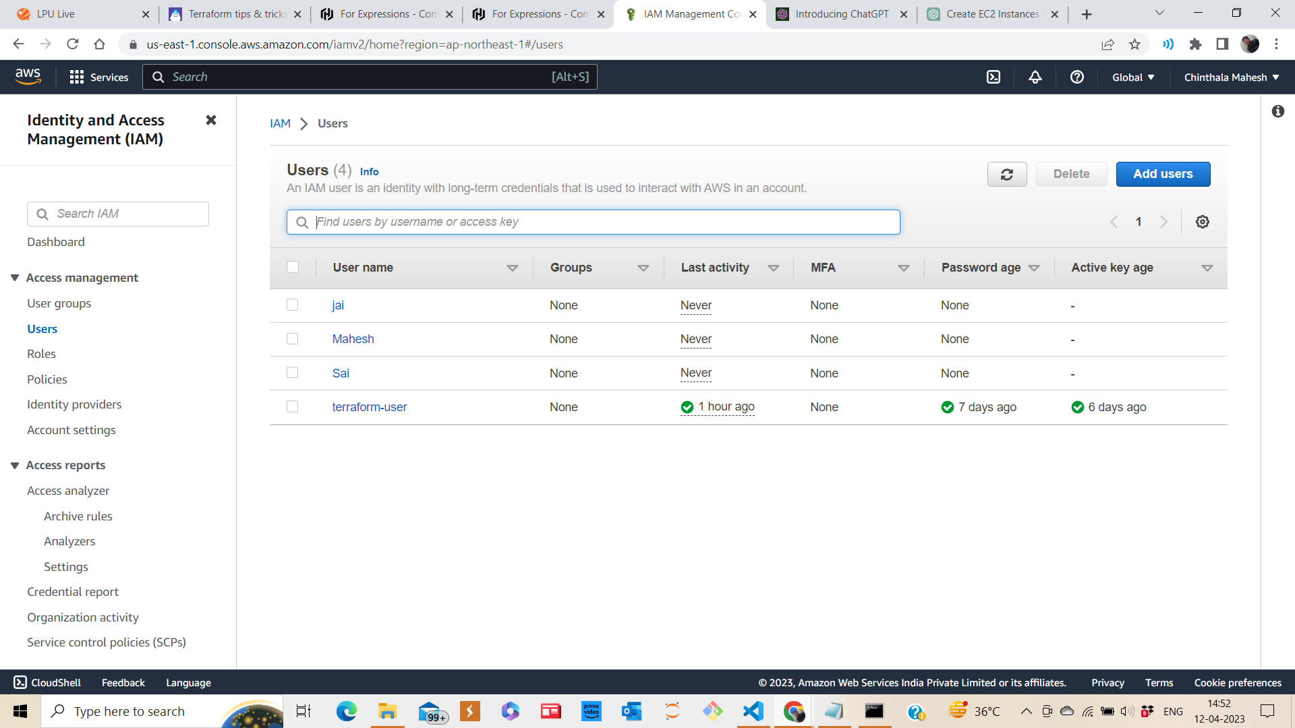

Users created, we can see in aws console.